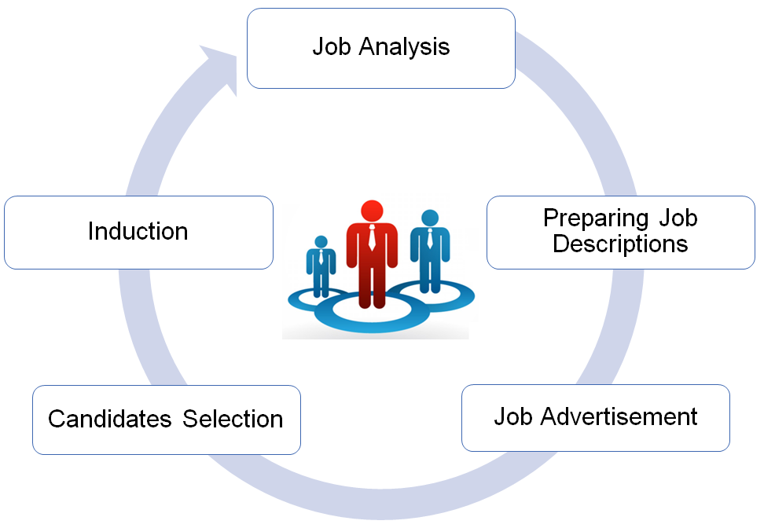
Step I: Job Analysis:
__________________________________________________________________________________________________________________________________________________________________________________________________________________
Step II: Preparing Job Description:
__________________________________________________________________________________________________________________________________________________________________________________________________________________
Step III: Job Advertisement:
__________________________________________________________________________________________________________________________________________________________________________________________________________________
Step IV: Candidates Selection:
__________________________________________________________________________________________________________________________________________________________________________________________________________________
Step V: Induction:
__________________________________________________________________________________________________________________________________________________________________________________________________________________

Note: Kindly attach the job descriptions of the positions proposed in Appendix B.

